CS 499 Module One Assignment Template

Complete this template by replacing the bracketed text with the relevant information.

- Self-Introduction: Address all of the following questions to introduce yourself.

  - How long have you been in the Computer Science program?
I have been in the Computer Science program for about two years.

  - What have you learned while in the program? List three of the most important concepts or skills you have learned.
During the program, I have learned a wide range of technical and problem solving skills. Three of the most important things I have learned are full stack development, data analysis using tools like SQL and Python, and how to design and work with databases. These skills have helped me understand how software systems work from end to end.

  - Discuss the specific skills you aim to demonstrate through your enhancements to reach each of the course outcomes.
Through my enhancements, I want to show that I can build and improve working software, analyze data in a clear and accurate way, and apply secure and organized coding practices. I also want to demonstrate that I can document my work, explain my decisions, and show that I understand how each part of a system connects to the final outcome.

  - How do the specific skills you will demonstrate align with your career plans related to your degree?
The skills I will demonstrate line up with my career goals because I want to move into data analytics and continue working in tech. Being able to collect, clean, and interpret data, as well as understand software systems, will help me in roles that involve problem solving and data driven decision making. These skills are needed in the type of work I plan to do after graduation.

  - How does this contribute to the specialization you are targeting for your career?
This contributes to my data analytics specialization because everything I am practicing strengthens my ability to understand data and build solutions around it. The coursework and enhancements help me prepare for real projects where I will need to work with databases, analyze trends, and present insights that support business or organizational needs.

- ePortfolio Set Up:

  - Submit a screen capture of your ePortfolio GitHub Pages home page that clearly shows your URL.

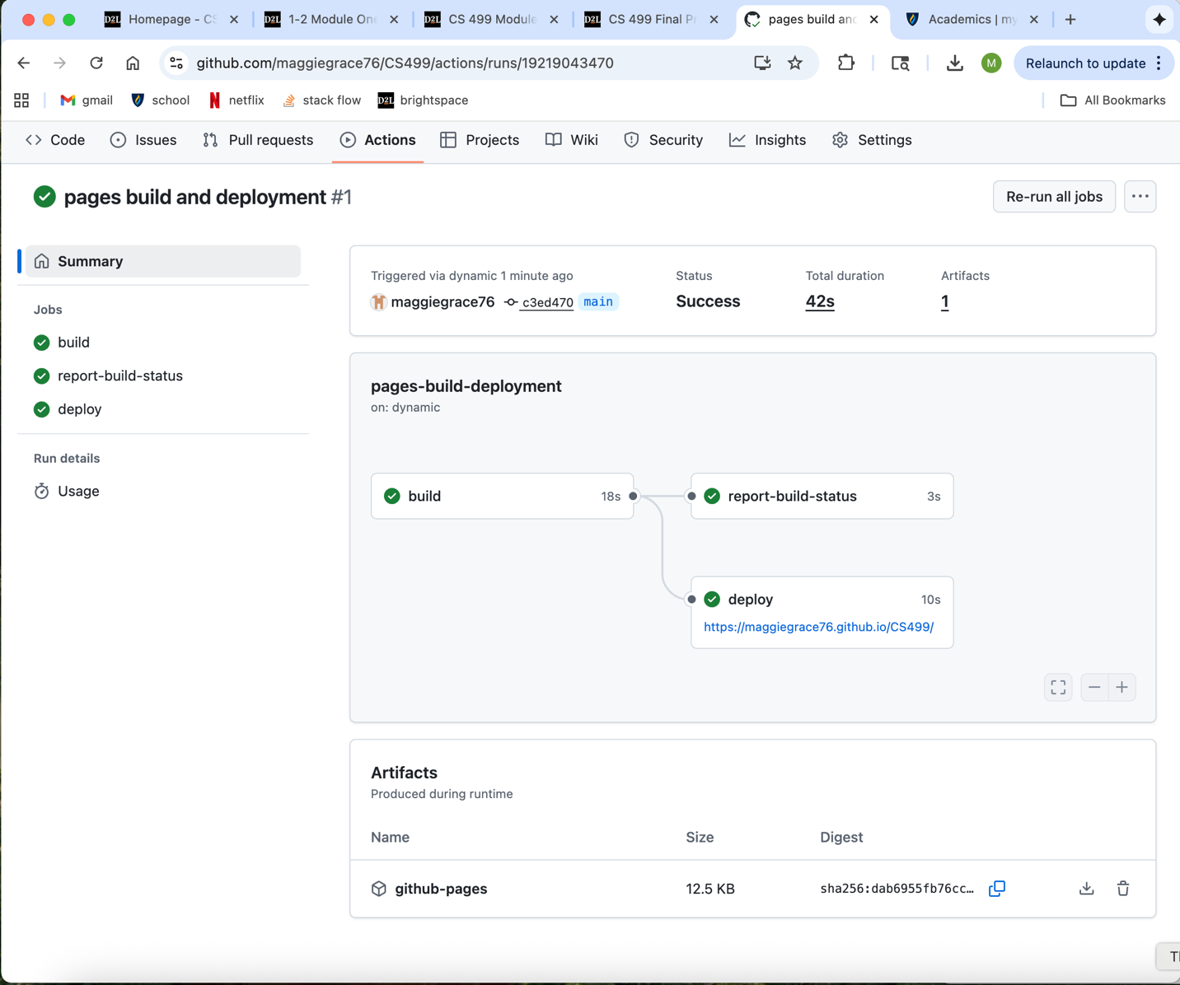

  - Use the GitHub Pages link in the Resource section for directions on:
    - How to create your GitHub website and publish code to GitHub Pages
    - Issues, such as adding links to other sites

  - Paste a screenshot of your GitHub Pages home page with your URL clearly showing in the space below.
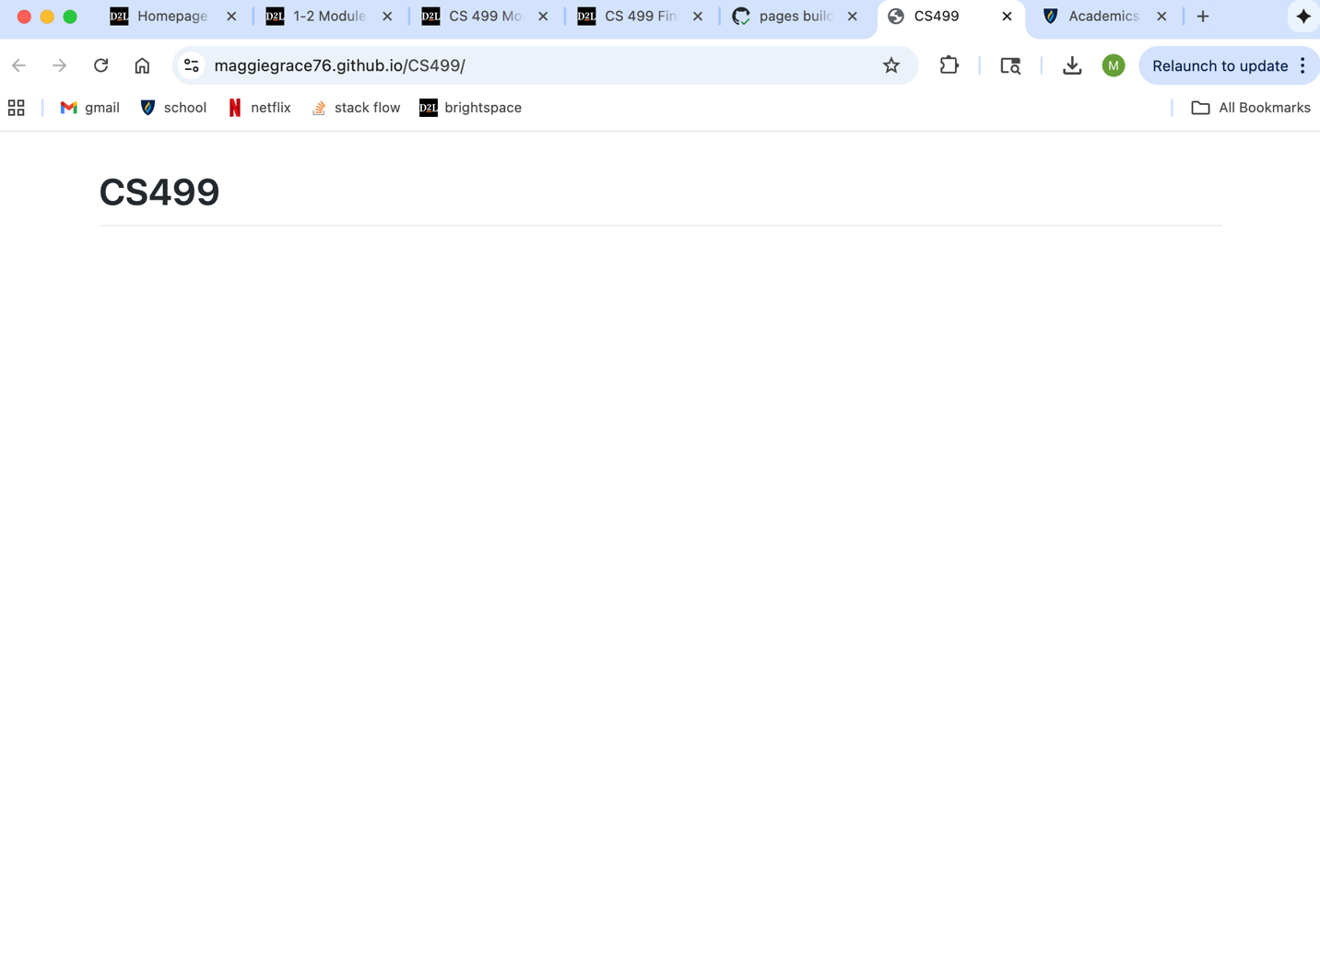

- Enhancement Plan:

  - Category One: Software Engineering and Design
    - Select an artifact that is aligned with the software engineering and design category and explain its origin. Submit a file containing the code for the artifact you choose with your enhancement plan.

IT 145: Foundation in Application Development

Note: Your artifact may be work from the following courses:

- IT 145: Foundation in Application Development
- CS 250: Software Development Lifecycle
- CS 260: Data Structures and Algorithms
- IT 315: Object Oriented Analysis and Design
- CS 320: Software Testing, Automation, and Quality Assurance
- CS 330: Computational Graphics and Visualization
- CS 340: Advanced Programming Concepts
- CS 350: Emerging Systems Architectures and Technologies
- CS 360: Mobile Architecture and Programming
- IT 365: Operating Environments
- IT 380: Cybersecurity and Information Assurance
- CS 405: Secure Coding
- CS 410: Reverse Software engineering
- IT 340: Network and Telecommunication Management
- IT 380: Cybersecurity and Information Assurance

I will refactor my CS 360 inventory app to separate the logic from the screens using IT 145 foundations. I will move database and calculation logic into a helper class called InventoryRepository and keep MainActivity and the item screens focused on user input and display only. I will add clear input validation for all item fields, friendly error messages, and simple tests by running sample inputs. I will also clean up naming, remove repeated code, and add short comments so the code is easier to read and maintain.

Scope: (General Idea might make changes not sure yet)
Create an InventoryRepository class that handles add, get, update, and delete.
Create a simple Item model class to hold item data.
Keep SQLite code inside the repository so activities only call methods.
Add input checks for name, quantity, and any required fields before saving.
Show clear messages for empty or invalid inputs.
Confirm that the list refreshes after add, edit, or delete.

Psuedocode:
Start the app
Show the login screen
User enters username and password
If either field is empty show a message and stop the login attempt
If both fields are valid check the credentials
If credentials are correct open the inventory list screen
If credentials are not correct show an error message and stay on the login screen
On the inventory list screen
Load items by calling InventoryRepository.getAll
Display the items in a list
When the user taps add open the add item screen
When the user taps an item open the edit item screen for that item
When the user taps delete on an item call InventoryRepository.delete and refresh the list
On the add item screen
User enters item name and quantity and any other fields
If item name is empty show a message and do not save
If quantity is empty or not a number show a message and do not save
If inputs are valid create an Item object with the values
Call InventoryRepository.add with the Item
If add succeeds return to the list screen and refresh items
If add fails show a message
On the edit item screen
Load the selected item values into the input fields
User changes values and taps save
If item name is empty show a message and do not save
If quantity is empty or not a number show a message and do not save
If inputs are valid update the Item object with new values
Call InventoryRepository.update with the Item
If update succeeds return to the list screen and refresh items
If update fails show a message
Inside InventoryRepository
When add is called open the database insert the item close the database and return success or failure
When getAll is called open the database read all items map each row to an Item close the database and return the list
When update is called open the database update the row for that id close the database and return success or failure
When delete is called open the database delete the row for that id close the database and return success or failure
End process when the user exits the app

For this category of enhancement, consider improving a piece of software, transferring a project into a different language, reverse engineering a piece of software for a different operating system, or expanding a project’s complexity. These are just recommendations. Consider being creative and proposing an alternative enhancement to your instructor.

Think about what additions to include to complete the enhancement criteria in this category. Since one example option is to port to a new language, that is the kind of scale that is expected. This does not mean you need to port to a new language but instead have an equivalent scale of enhancement. Underlying expectations of any enhancement include fixing errors, debugging, and cleaning up comments, but these are not enhancements themselves.

    - Explain how the planned enhancement will demonstrate specific skills and align with course outcomes.

      - Identify and describe the specific skills you will demonstrate that align with the course outcome.

By completing this enhancement, I will demonstrate several software engineering and design skills that I originally learned in IT 145. These include organizing code into separate classes, improving the structure of methods, adding clear input validation, and separating logic from the user interface. I will apply these skills to my CS 360 inventory app to make the project cleaner and easier to maintain. I will also demonstrate my ability to analyze existing code, identify weak points, and refactor it into a more logical and consistent format. These skills show that I can improve an existing application and use strong design practices to make the code more reliable and easier to work with.

      - Select one or more of the course outcomes below that your enhancement will align with.

By completing this enhancement, I will be demonstrating skills that directly connect to Course Outcomes 3 and 4. The goal of my enhancement is to take the core structure of my CS 360 inventory app and improve it using the programming foundations I learned in IT 145. This includes reorganizing the code so the logic is separated from the screens, creating a helper class to handle the main operations, and adding structured methods that make the app easier to read and maintain. I will also add input validation so the app does not accept empty or incorrect values, which makes the overall solution stronger and more dependable. These steps reflect Course Outcome 3 because I am reviewing my existing design, identifying weaknesses, and improving the way the app solves the problem through better logic and cleaner structure. I am making design choices that strengthen the solution while thinking about the trade-offs involved in how the code is organized. This enhancement also aligns with Course Outcome 4 because I am using reliable and practical programming techniques to upgrade the app without changing its purpose. By applying IT 145 skills to a more advanced project, I am showing that I can use foundational methods to improve a real mobile application. This includes using classes, methods, validation, and clear logic to make the program more efficient and easier for future developers to understand. Together, these improvements show that I can use well-founded techniques to deliver value and produce a better version of the inventory app that meets industry expectations for clean and organized software.

Course Outcomes:

- Employ strategies for building collaborative environments that enable diverse audiences to support organizational decision-making in the field of computer science.
- Design, develop, and deliver professional-quality oral, written, and visual communications that are coherent, technically sound, and appropriately adapted to specific audiences and contexts.
- Design and evaluate computing solutions that solve a given problem using algorithmic principles and computer science practices and standards appropriate to its solution while managing the trade-offs involved in design choices.
- Demonstrate an ability to use well-founded and innovative techniques, skills, and tools in computing practices for the purpose of implementing computer solutions that deliver value and accomplish industry-specific goals.
- Develop a security mindset that anticipates adversarial exploits in software architecture and designs to expose potential vulnerabilities, mitigate design flaws, and ensure privacy and enhanced security of data and resources.

  - Category Two: Algorithms and Data Structures

- Select an artifact that is aligned with the algorithms and data structures category and explain its origin. Submit a file containing the code for the artifact you choose with your enhancement plan. You may choose work from the courses listed under Category One.

CS360: Mobile Architecture and Programming

- Describe a practical, well-illustrated plan for enhancement in alignment with the category, including a pseudocode or flowchart that illustrates the planned enhancement.

For this enhancement, I will improve how my CS 360 app handles data by adding more efficient data structures and simplifying the way items are loaded and updated. Right now, the app pulls all data directly from SQLite each time the list screen opens. I plan to introduce an in-memory list that temporarily stores the items after they are loaded from the database so the app can access them more quickly. I will also reorganize the code so that all list updates go through one central method, which will reduce repeated logic and make the data handling cleaner. This enhancement fits the algorithms and data structures category because it improves how the app processes, stores, and retrieves information.
I will also add simple sorting so the inventory list appears in alphabetical order or by quantity. This involves implementing a basic sorting algorithm or calling a built-in sorting method on the list before displaying it. This will make the app easier to use and demonstrate that I can apply algorithmic thinking to improve functionality. After these changes, the data flow will be clearer, faster, and more organized.

Start the app
Load the login screen and allow the user to sign in
After login, load all items from SQLite one time
Store all loaded items in an in-memory list called itemList
Sort itemList using a simple sorting method
Display the sorted list on the screen
When the user adds a new item
Validate the item name and quantity
If the input is valid, add the item to SQLite
Add the same item to itemList
Sort itemList again
Refresh the displayed list
When the user edits an item
Validate the updated values
If the values are valid, update the item in SQLite
Update the matching item in itemList
Sort itemList again
Refresh the displayed list
When the user deletes an item
Delete the item from SQLite
Remove the same item from itemList
Refresh the displayed list
End the process when the user closes the app

- Explain how the planned enhancement will demonstrate specific skills and align with course outcomes.

  - Identify and describe the specific skills you will demonstrate to align with the course outcome.

By completing this enhancement, I will demonstrate skills related to choosing and working with appropriate data structures, organizing data flow, and improving the way an application processes information. Adding an in-memory list shows that I can use data structures to reduce unnecessary work and make the app faster. Sorting the list shows that I understand basic algorithmic principles and can apply them to real program features. Updating one central data structure and keeping it in sync with the database also shows that I can design cleaner and more efficient workflows. These skills demonstrate my ability to evaluate an existing solution and improve it using better data handling techniques.

  - Select one or more of the course outcomes listed under Category One that your enhancement will align with.

By completing this enhancement, I will demonstrate skills that directly support Course Outcomes 3 and 4. I am improving how my CS 360 inventory app handles data by introducing an in-memory list, adding sorting, and organizing the data flow so the app works more efficiently. These updates show that I can design and evaluate computing solutions by applying algorithmic principles that make the program run smoother and avoid repeated work, which aligns with Course Outcome 3. I am taking the existing structure of the app and improving it through better data handling, more organized logic, and clearer workflows. This enhancement also supports Course Outcome 4 because I am using practical and well-founded techniques to strengthen the app and make it more efficient for real use. Reworking the way items are loaded, stored, and updated demonstrates that I can use established data structures and coding practices to deliver better performance and maintainability, which reflects what is expected in industry level software.

  - Category Three: Databases

    - Select an artifact that is aligned with the databases category and explain its origin. Submit a file containing the code for the artifact you choose with your enhancement plan. You may choose work from the courses listed under Category One.

CS340 CRUD module

    - Describe a practical, well-illustrated plan for enhancement in alignment with the category, including a pseudocode or flowchart that illustrates the planned enhancement.

My plan is to enhance the CS 340 CRUD module by adding more advanced database features that match real use cases. I will expand the read function so it can accept multiple filters at the same time, which allows more flexible searches. I will also improve how the module organizes data by sorting the results and allowing the user to load data in smaller groups instead of pulling everything at once. These changes make the module more efficient and easier to use when the database grows. To make the tool more practical, I will add a feature that exports the results into a CSV file so the data can be used outside the program. I also plan to add input checks before running queries and include error messages if something goes wrong. This makes the module more reliable and supports my work from IT 145, where I learned the importance of clean structure and validation. It also ties into the organized design I used when enhancing my CS 360 inventory app because both projects benefit from clear logic and dependable data handling.

Psuedocode:

Start the module and connect to the MongoDB database.
If the user wants to search for data, read the search values and check that they are valid.
If the values are valid, build a MongoDB query that uses the selected filters.
Run the query and collect the results.
If sorting is needed, sort the results before returning them.
If the user wants results in smaller groups, return only a portion of the list.
If the user wants to add new data, check that all required fields are filled in, then insert the record into the database.
If the user wants to update data, check the record id and new values, then run the update and return confirmation.
If the user wants to delete data, check the record id and run the delete operation.
If the user chooses to export, take the list of results and write them to a CSV file.
End the process when the user is finished.

For this category of enhancement, consider adding more advanced concepts of MySQL, incorporating data mining, creating a MongoDB interface with HTML/JavaScript, or building a full stack with a different programming language for your artifact. These are just recommendations; consider being creative and proposing an alternative enhancement to your instructor. Note: You only need to choose one type of enhancement per category.

Think about what additions to include to complete the enhancement criteria in this category. Since one example option is to port to a new language, that is the kind of scale that is expected. Perhaps you might increase the efficiency and time complexity of an algorithm in an application and detail the logic of the increased time complexity. Remember, you do not need to port to a new language but instead have an equivalent scale of enhancement. Underlying expectations of any enhancement include fixing errors, debugging, and cleaning up comments, but these are not enhancements themselves.
    - Explain how the planned enhancement will demonstrate specific skills and align with course outcomes.

For this enhancement, I will be demonstrating database skills such as building stronger queries, organizing data flow, validating inputs, and exporting information into a usable format. I will also be showing that I can take an existing system and make it more efficient and more flexible by improving the way it communicates with the database. These skills connect to my IT 145 enhancement because both projects focus on cleaning up logic, using structured methods, and making the program easier to maintain. They also tie in with my CS 360 artifact because that project relied heavily on organized data handling, which is something I am now improving even further in this enhancement.

      - Select one or more of the course outcomes listed under Category One that your enhancement will align with.

This enhancement aligns with Course Outcomes three and four. It aligns with Course Outcome three because I am designing and evaluating a stronger database solution by adding filters, sorting, pagination, and clearer workflows. I am improving the way the system solves problems by making database operations more effective. It aligns with Course Outcome four because I am using practical and widely accepted techniques to strengthen the module and make it more valuable. By expanding the CRUD functions and adding new features, I am delivering a more complete and useful database tool that reflects real industry needs.

- ePortfolio Overall Skill Set

  - Accurately describe the skill set to be illustrated by the ePortfolio overall.
    - Skills and outcomes planned to be illustrated in the code review

In the code review, I plan to show my ability to design, organize, and improve software by walking through the main logic of my projects. I will highlight how I used structured programming skills, problem solving, and clean design to build working applications in Java, Android, and Python. I will demonstrate how I apply coding standards, break programs into smaller parts, refactor code to make it clearer, and use algorithms and data handling correctly. The review will also show how I identify issues, test the code, and explain why certain design choices were made. This connects to course outcomes three and four because I will be showing how I design solutions and use tools and techniques that support reliable software development.

    - Skills and outcomes planned to be illustrated in the narratives

In the narratives, I will explain how each artifact was created, why it matters, and how I enhanced it to make it better. I will describe my thought process, the challenges I faced, and the decisions I made to solve problems in meaningful ways. The narratives will show my ability to communicate clearly about technical topics in a way that makes sense to different audiences. I will connect my work to real software practices such as planning, designing, debugging, data management, and improving performance. This aligns with course outcome two because I will be writing clear, technically sound explanations that show understanding of both the code and the purpose behind it.

    - Skills and outcomes planned to be illustrated in the professional self-assessment
In the professional self-assessment, I will show that I understand my strengths as a computer science student and future professional. I will explain how my experiences across IT 145, CS 360, and CS 340 helped me grow in areas like problem solving, planning, communication, and adapting to new tools. I will reflect on the skills I feel confident with as well as the ones I want to continue improving. I will connect my growth to the course outcomes by explaining how I now understand design choices, software development practices, and the value of organized code. The self-assessment will show that I can look at my work honestly and understand how to carry these skills forward into my career.

